OCEANA COUNTY

**JUNIOR MARKET**

**CHICKEN RECORD BOOK - 2024**

**(for ages 5-7)**

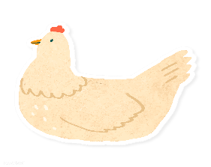

As a member of the Junior Market Animal Project, you are required to submit your records as part of an educational project notebook in order to show your animal at the Oceana County Fair. **This notebook must be shown to the Poultry Superintendent or designated Small Market Weighmaster at the time of weigh-in and then entered by you in the Educational Notebook Division at the Oceana County Fair on Entry Day.**

IF YOU ARE A LITTLE BUDDY PLEASE CHECK HERE: _____

My big buddy is: _________________________________________

**NUMBER OF YEARS IN PROJECT: __________**

**AGE: __________**

Your age you enter depends on how old you were on January 1, 2024.

Use this sheet as the first page of your project record book. Fill it out completely.

**Please print or type neatly**.

# NAME ____________________________________________________________________________

4-H CLUB _________________________________________________________________________

LEADER __________________________________________________________________________

##### DATE RECORDS STARTED ___________________ DATE ENDED ____________________

**JUDGE’S SCORE/COMMENT SHEET**

**(PLEASE DO NOT REMOVE, PLACE THIS SHEET IN SHEET PROTECTOR OR GLUE TO COVER). This sheet must be keep free to the judge to write their comments.**

This sheet should help each junior market member understand their ribbon placing.

A. **Specific educational value or worth**

___ All questions were answered completely

___ All calculations were correct

___ Calculations were incorrect

___ Questions were not completely answered

___ Questions were not answered (missed questions)

B. **Notebook contains all project records**

___ Notebook contained all project records and were fully completed

___ Notebook contained additional project related information (research

materials etc.)

___ Project records were incomplete

___There was no additional project related information

C. **Accuracy, neatness and general appearance**

___Notebook was neat in appearance (typed/hand printed)

___ Notebook pages were clean and stain free

___Notebook pages were in order and complete

___Notebook pages were out of order and missing pages

___Notebook was difficult to read and messy

___Notebook had wrinkled and stained pages

Other Comments:

__________________________________________________________________________________________

__________________________________________________________________________________________

______________________________________________________________________

2024-JUNIOR MARKET CHICKENS PAGE 2

## OBJECTIVES

1. Develop desirable work habits, sportsmanship, and ability to cooperate and express ideas through participation in projects, discussions, method demonstrations, judging teams, and exhibits.
2. Experience the pride and responsibility of leasing/owning and caring for poultry.
3. Learn how to feed, fit, show, breed and raise poultry.
4. Learn proper handling procedures to prevent injuries to members and their poultry projects.
5. Appreciate and use scientific information in poultry production and marketing.
6. Improve knowledge of grading, marketing and merchandising of poultry and poultry products.
7. Improve knowledge of the nutritive value of poultry meat and eggs and how they contribute toward good health.
8. Learn the importance of the poultry industry to the local, state, and national economies.
9. Acquire information on the opportunity that poultry offers as a career.

This record book is part of your Junior Market Chicken project. By keeping records up-to-date you will be able to see how much progress you make as you set goals and work to accomplish them. Write or type neatly and clearly. Please keep the pages in order. Feel free to add extra pages at the end of your notebook. Pictures are a required part of your notebook. Taking pictures of your project animal throughout the project will indicate how your animal has grown and developed. Add pictures to your notebook on a separate piece of paper.

SCORING CRITERIA

The following breakdown will be used during the judging process of all market livestock notebooks.

A. Specific educational value or worth **30%**

B. Creative way of showing what has been learned **10%**

C. Notebooks contains all project records **50%**

D. Accuracy, neatness and general appearance **10%**

The Oceana County Agricultural Society encourages parent assistance with your project and project notebook.

**If a parent or adult helped you in filling out your notebook please have them sign below that the answers are YOUR answers and that they assisted you in writing of the answers and understanding of the questions only.**

________________________________________________________________________________

(Signature of person helping with notebook)

________________________________________________________________________________________

(Printed name by member)

2024-JUNIOR MARKET CHICKENS PAGE 3

**ABOUT YOUR CHICKENS**

***My Chicken’s Names*** ***are:***  (if you did not name your market chickens, what is the name of your showmanship chicken)

________________________________________________________________________

***My Chicken’s breeds*** ***are***: ______________________________________________

***What color are your Chickens***? _________________________________________

***My Chickens favorite thing to do is***: ___________________________________

________________________________________________________________________

## WEIGHT CHART

|  |  |  |
| --- | --- | --- |
| Date | Age | **Weight** |
|  |  |  |
|  |  |  |
|  |  |  |
|  |  |  |
|  |  |  |

**FINAL WEIGHT (FW)___________ AGE__________ DATE___________**

2024-JUNIOR MARKET CHICKENS PAGE 4

## EXPENSES

##### (A) Cost of chicks $_______________________

|  |  |  |  |
| --- | --- | --- | --- |
| **DATE** | LBS. OF FEED | FEED TYPE/VARIETY | COST |
|  |  |  | **$** |
|  |  |  |  |
|  |  |  |  |
|  |  |  |  |
| **(B)** |  | **TOTAL SPENT ON FEED** | **$** |

|  |  |  |
| --- | --- | --- |
| **DATE** | OTHER EXPENSES, VET, SUPPLIES, HOUSING, ETC. | COST |
|  |  | **$** |
|  |  |  |
|  |  |  |
|  |  |  |
| **(C)** | **TOTAL SPENT ON OTHER EXPENSES** | **$** |

##### GRAND TOTAL OF ALL EXPENSES (TE): $ _______________________

**(total of A, B and C)**

**_______________ ÷ _________________ = __________________________________________**

Total Expenses **(TE)** + Final Weight **(FW)** Break Even Price **(BE)**

(or total cost per pound to raise your animal)

**+ Final Weight may need to be estimated depending on Covid restrictions in summer of 2021.**

***\*\* have your parent, leader or an older teen in your club help you figure out your breakeven price. The breakeven price is the price that you need to get at the***

***Junior Market animal auction in order to not lose money on your market project. \*\****

2024-JUNIOR MARKET CHICKENS PAGE 5

**ANIMAL CARE AND MANAGEMENT- JOURNAL OF CARE**

Your project requires regular care and management.

Include the following:

* Feeding and watering practices
* Health practices and medicines (vaccinations, etc.)
* General Management (building a cage, cleaning living area, feed pans, etc.)

|  |
| --- |
| **Daily- Things done once or twice a day** |
|  |
| **Weekly- Things done once or twice a week** |
|  |
| **Monthly- Things done once a month** |
|  |
| **Yearly- Things done one time or occasionally throughout the year** |
|  |

2024 JUNIOR MARKET CHICKENS PAGE 6

**MARKETING**

One of the most important parts of any market animal project is marketing. This may include writing letters and talking to prospective buyers. Color in the face, a smiling face is a good action, a frowning face is a bad action. (see the example)

**Good Marketing Practice Poor Marketing Practice**



















Send a picture to your potential buyers

Send a reminder to attend the auction

Let an adult talk to the buyer instead of you talking to them

Know what kind of feed you use if asked

Make sure to only visit your previous buyers

Only thank those who agree to be listed as a potential buyer

**WHAT DOES YOUR CHICKEN NEED?**

(have an adult help you read the following & then **circle those items that your chickens** need below)

All living creatures need certain things to survive, like *food*, *water* and shelter. *Farmers* take care of their animals to make sure they are healthy and comfortable. If any chickens are sick the farmer will treat them with the help of the *veterinarian, they may need vaccinations.* Chickens like food such as *corn kernels* as they scratch the ground for food.

HAMBURGER CHOCOLATE CHIPS FARMER   

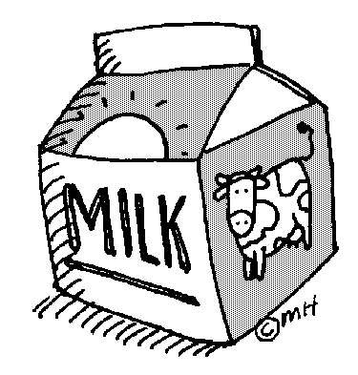

BARN

FARMER

BIKE

JUICE

WATER

CLOTHES

MILK

CORN

VETERINARIAN

TV

CAKE

CAKE CORN VETERINARIAN

VACINATIONS COOP WATER

2024-JUNIOR MARKET CHICKENS PAGE 7

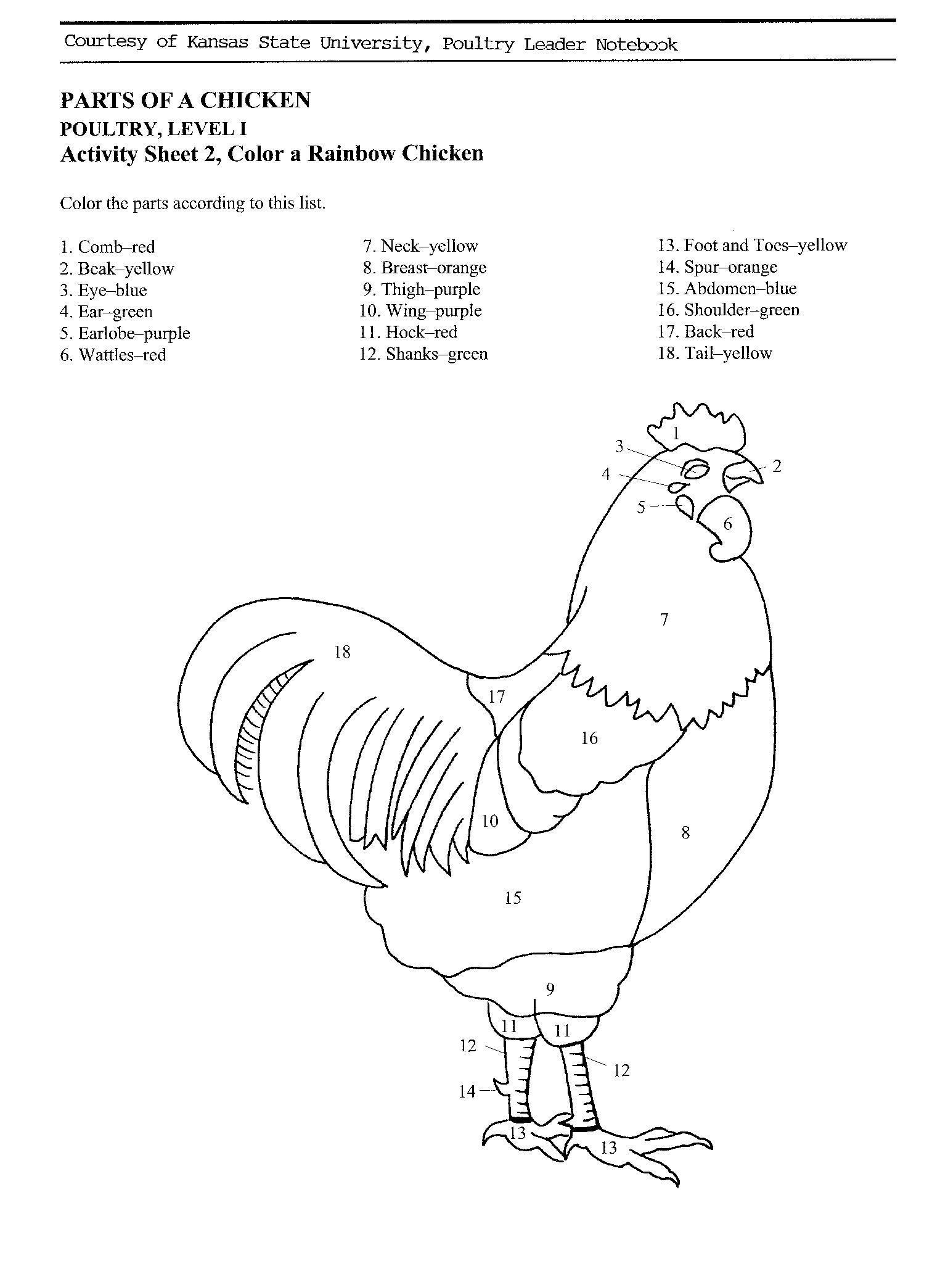

2024-JUNIOR MARKET CHICKENS PAGE 8

**SHOWMANSHIP**

Page 8

SMA Chickens

**HATCH**

**PULLET**

**VENT**

**SCALES**

**COOP**

**HEN**

**ROASTER**

**PUREBRED**

**EMBRYO**

**ROOSTER**

**MOLT**

**SHANK**

(number the showmanship steps in the correct order)

____ Examining Feet and Legs

____ Measuring Depth of Abdomen

____ Showing Width of Body

____ Carrying the Bird

____ Measuring Width of Pubic Bones

____ Checking the Breast

____ Examining Undercolor

____ Examining Head

____ Examining Wings

____ Posing the Bird

**PROJECT INFORMATION**

Write the letter in front of the word from the correct definition.

**DEFINITIONS:**

A. Fleshy protruding part on top of the head of a chicken.

B. A young, meat-type chicken, usually processed before

eight weeks of age.

C. Place between the neck & body where food is

temporarily stored and softened for digestion.

D. The single body opening in birds.

E. A female chicken less than one year old.

F. Skin growing between the toes, also triangular area of

skin in front and between the joints of the wing.

G. A female chicken one year old or older.

H. Miniature chickens usually ¼ to 1/5 the size of a regular

or large fowl.

I. A place where poultry are housed or exhibited.

**WORD**

_____CROP

_____PULLET

_____COMB

_____BROILER

_____COOP

_____VENT

_____BANTAM

_____WEB

_____HEN

2024-JUNIOR MARKET CHICKENS PAGE 9

**TRUE OF FALSE**

(circle T for True or F for False)

1. Placing a bird in its carrying crate a couple of times before show

day is a good way to train it to be calm when in its crate T F

2. When removing a bird from its cage, you should remove its

head first. T F

3. If your bird moves both legs during posing, keep trying to

repose it until you get it to stand still. T F

4 When cleaning your bird’s feathers, go from head to tail; do not go against the feathers. T F

5. A place where poultry are housed or exhibited is its stall. T F

6. During judging be alert & smile, look at the judge from time to

time and be courteous. Answer the judge’s questions

politely using the words “sir” or ma’am.” T F

7. A cloverbud is a 4-Her ages 5-7 who must have an adult close

Page 9

SMA Chickens

by when handling their poultry animals. T F

8. For your market project you must sell a pen of 2 chickens. T F

9. Each market chicken must weigh a minimum of 8 pounds. T F

10. Your poultry must be checked for pollorum on entry day of Fair

at the Oceana County Fair? T F

11. You must accumulate 9 points in order to sell your animal,

6 from 4-H meetings and 3 from nonclub points. T F

12. You can learn the breeds by studying the Standards of

Perfection. It will also tell what a “perfect” bird is. T F

13. Water is not very important to your chicken, if you forget to

give it fresh water frequently it is okay. T F

14. You will show your **market** chickens during showmanship. T F

2024 JUNIOR MARKET CHICKENS PAGE 10

**PROJECT INFORMATION**

**What Does Not Belong?**

In each statement one word does not belong, ***X (cross)*** out that word.

1. Poultry have: **beaks, ears, eyes, gizzards, hooves**

2. Poultry eat: **insects, green potato skins, water, grasses**

3. The people who help me take care of and learn about my flock are:

**my principal, my club leader, the veterinarian, my parents**

4. Chicken breeds: **Silkie, Hereford, Plymouth Rock, Polish**

**Finish the Sentences**

1. My flock always needs clean, fresh __________________________________ to drink.

2. When I grow up I want to be a _________________________________________________.

3. The best, or most fun, part of my project was: __________________________________

_______________________________________________________________________________

_______________________________________________________________________________

______________________________________________________________________________

_______________________________________________________________________________

4. The hardest part of my project was: ____________________________________________

_______________________________________________________________________________

_______________________________________________________________________________

_______________________________________________________________________________

_______________________________________________________________________________

2024-JUNIOR MARKET CHICKENS PAGE 11

**IDENTIFY GOOD AND BAD CHARACTER ACTIONS**

Color in the face, a smiling face = a good action; a frowning face = a bad action.

**RAISING and SHOWING an RAISING and SHOWING an**

**ANIMAL *with* CHARACTER ANIMAL *without* CHARACTER**









































Feed Animals on Time

Complain about judge

Clean cages whenever you feel like it

Thank the judge for their time

Congratulate whoever places first

Congratulate whoever places first

Help others if they need it

Leave animals outside without shelter

Have your leader complete your record book

Insult competitors

**4-H INFORMATION**

How did you show good character this year? Did you help someone, or maybe you treated your animals extra special?

__________________________________________________________________________________________

__________________________________________________________________________________________

__________________________________________________________________________________________

2024-JUNIOR MARKET CHICKENS PAGE 12

**LEARN THE LIFE CYCLE OF A CHICKEN AS YOU COLOR THE PICTURE**

**4-H KNOWLEDGE**

**The 4-H Pledge**- *Draw a line to the picture that fills in the blank* (see the example)

***I pledge…***

HANDS

HEALTH

HEAD

HEART

WORLD

COUNTRY

CLUB

COMMUNITY







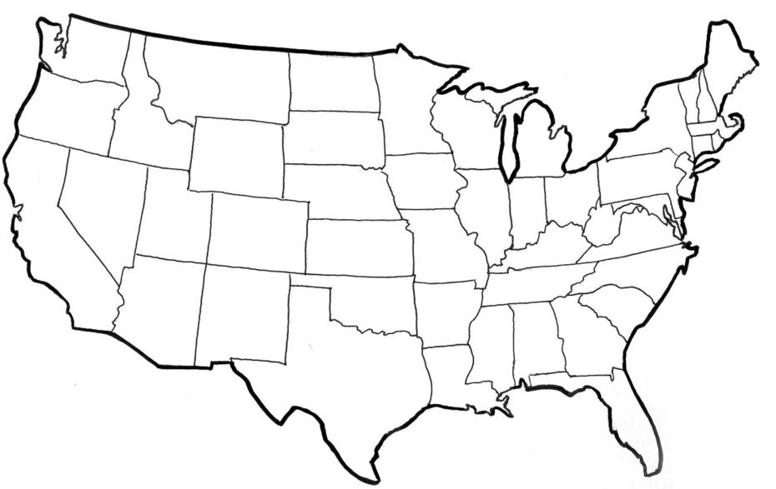





My ____________ to clearer thinking,

My ____________ to greater loyalty,

My ____________ to larger service, and

My _____________ to better living,

for my ____________________,

my _______________________,

my _______________________,

and my ____________________.

Number of club meetings held: **__________** Number I attended: **_________**

2024-JUNIOR MARKET CHICKENS PAGE 13

**MY STORY**

(Interesting things that happened to me and my animal this year, challenges, highlights of my year or ***ANYTHING*** I would like to share about my overall

experience. You can even draw a picture of you and your animals if you prefer).

***POTENTIAL BUYERS NAMES***

As part of your 4-H Small Market Livestock Project, you must personally contact at least five potential buyers before the Oceana County Fair. You are encouraged to seek two new buyers that have not been asked or submitted before. **You also must have at least three different buyers than those of your siblings in the market livestock project.** Please confirm with your buyers their accurate mailing address (example: post office box vs. a street address). The information on page 14 must be completed and taken to the Oceana County MSU Extension Office on or before the due date where it will be **copied** and used to send out letters to your potential buyers. This page will remain in your notebooks. This is a Market Livestock Committee rule. Failure to comply will result in not being able to sell your animal in the 4-H Market Livestock Sale.

2024-JUNIOR MARKET CHICKENS Date:__________________

Staff: _______________

**JUNIOR MARKET/SMALL MARKET POTENTIAL BUYER’S LIST**

**CHICKEN PROJECT (AGES 5-7)**

Name______________________________ Club_________________________

***Please print business names and complete addresses clearly.***

* 1. Contact Name ________________________________________________­­____

Business Name ____________________________________________________

**Mailing** Address _________________________City__­­­­­­­­__­­­­­­­_____________Zip_____

Phone _______________________ After Hours Phone______________________

Mailing Preference (Please Check One): Email ____ Postal Delivery ____

Email ____________________________________________________________

Signature__________________________________________________________

2. Contact Name ________________________________________________­­____

Business Name ____________________________________________________

**Mailing** Address _________________________City__­­­­­­­­__­­­­­­­_____________Zip_____

Phone _______________________ After Hours Phone______________________

Mailing Preference (Please Check One): Email ____ Postal Delivery ____

Email ____________________________________________________________

Signature__________________________________________________________

3. Contact Name ________________________________________________­­____

Business Name ____________________________________________________

**Mailing** Address _________________________City__­­­­­­­­__­­­­­­­_____________Zip_____

Phone _______________________ After Hours Phone______________________

Mailing Preference (Please Check One): Email ____ Postal Delivery ____

Email ____________________________________________________________

Signature__________________________________________________________

(Must be stamped by the MSU Extension Office)

2024-JUNIOR MARKET CHICKENS PAGE 15

**PICTURES OF YOUR PROJECT**

(Please use this page for your project pictures. Add additional pages if you would like. The judges appreciate you labeling the pictures so they know what the picture shows.)

***NON-CLUB* POINTS- JUNIOR/SMALL MARKET PROJECT**

***(This must be filled out by participant before presenting for signatures at the MSUE office)***

|  |  |  |  |  |
| --- | --- | --- | --- | --- |
| **MEETING NAME** | **LOCATION** | **DATE** | **POINTS** | **SIGNATURE OF LEADER, SUPERINTENDENT OR MSU STAFF** |
|  |  |  |  |  |
|  |  |  |  |  |
|  |  |  |  |  |
|  |  |  |  |  |
|  |  |  |  |  |
|  |  |  |  |  |
|  |  |  |  |  |
|  |  |  |  |  |
|  |  |  |  |  |
|  |  |  |  |  |

Please note: This form must be included with your record notebook and turned into the weigh master on entry day of the Fair. **BEFORE SEEKING SIGNATURES AT MSU EXTENSION – MEETING NAME AND DATE MUST BE COMPLETED** You need to accumulate **nine (9) points** to be allowed to sell your animal. **Six (6)** of these **nine (9) points** must come from club meetings. The **three (3)** non-club points must be earned from attending various 4-H events and activities. See your leader, the MSUE office, or online at <https://www.canr.msu.edu/oceana/oceana_county_4_h/oceana_4_h_market_livestock> for a listing of approved nonclub points.

**JUNIOR/SMALL MARKET PROJECT CLUB POINTS**

***(This must be filled out by participant before presenting for signatures at the MSUE office)***

|  |  |  |  |  |
| --- | --- | --- | --- | --- |
| **MEETING NAME** | **LOCATION** | **DATE** | **POINTS** | **SIGNATURE OF LEADER, SUPERINTENDENT OR MSU STAFF** |
|  |  |  |  |  |
|  |  |  |  |  |
|  |  |  |  |  |
|  |  |  |  |  |
|  |  |  |  |  |
|  |  |  |  |  |
|  |  |  |  |  |
|  |  |  |  |  |
|  |  |  |  |  |
|  |  |  |  |  |
|  |  |  |  |  |

Please note: This form must be included with your record notebook and turned into the weigh master on entry day of the Fair. You need to accumulate **nine (9) points** to be allowed to sell your animal. **Six (6)** of these **nine (9) points** must come from club meetings. The **three (3)** non-club points must be earned from attending various 4-H events and activities